Task 1:-

Create a table comparing at least three types of WAN connections (such as leased line, DSL, and MPLS) with columns for speed, cost, and typical use cases.
Feature | Leased Line | DSL (Digital Subscriber Line) | MPLS (Multi-Protocol Label Switching)
Speed / Bandwidth | High to Very High (Symmetric, e.g., 10 Mbps to 10 Gbps) | Medium (Asymmetric, typically 5 Mbps to 100+ Mbps) | Very High and Scalable (Customizable bandwidth options)
Cost | Very High (Expensive monthly recurring costs) | Low to Medium (Very cost-effective) | High (More expensive than DSL, but highly efficient)
Typical Use Cases | Connecting major corporate headquarters or data centers requiring guaranteed, uninterrupted uptime. | Small businesses, branch offices, or remote workers needing basic, affordable internet access. | Medium-to-large enterprises connecting multiple geographically dispersed offices requiring secure, prioritized traffic (like VoIP).

2. Draw a labeled diagram (on paper or using any drawing tool) showing how a CSU/DSU connects a router to a WAN service provider, and explain the role of each device in 2-3 sentences.
>
The Router acts as the internal gateway, generating digital data packets for local networking. The CSU/DSU acts as a translator; the DSU (Data Service Unit) converts the router's digital signals into the specific communication format used by the service provider, while the CSU (Channel Service Unit) physically connects to the telecom line, managing line conditioning and protecting against signal interference. Together, they bridge the gap between a private local network and a public wide-area telecommunications network.
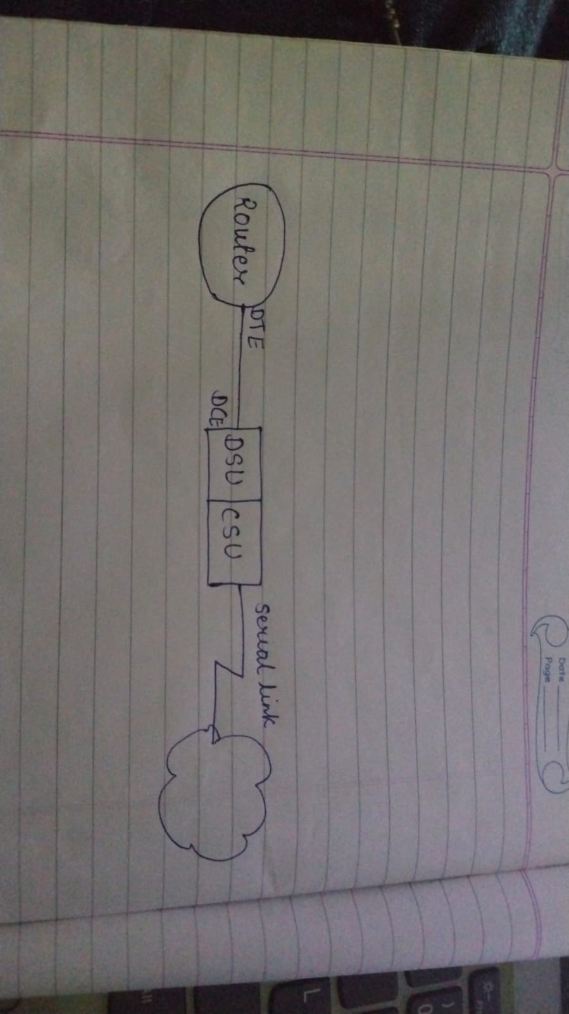

3. List three real-world examples of popular apps or services (like IRCTC, WhatsApp, or Zomato) that rely on WAN connections, and briefly describe how WAN enables their functionality.
>
IRCTC (Indian Railway Catering and Tourism Corporation): * How WAN enables it: IRCTC relies on a massive WAN to link thousands of ticket booking counters, mobile applications, and web servers scattered across India to a centralized core database. This allows real-time synchronization of train seat availability, payments, and ticket generation simultaneously from any location.
WhatsApp: * How WAN enables it: When you send a message, it travels globally across cellular towers, submarine cables, and localized internet routing architectures (WAN) to reach centralized data storage and processing cloud centers before instantly routing the message back down to the recipient’s global network location.
Zomato: * How WAN enables it: Zomato relies on a WAN structure to bridge communications instantly between three separate networks: the customer app, the restaurant's point-of-sale interface, and the delivery partner's GPS tracking system, handling live coordination and payment gateways over distinct geographic areas.

4. Research online and find an image or datasheet of a physical WAN aggregator device used in enterprise networks. Paste the image or link, and write two key features of that device.
>
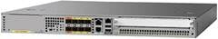
High-Density Connectivity & Aggregation: It features built-in 6 Gigabit Ethernet SFP ports and 2 built-in 10 Gigabit Ethernet SFP+ ports. This allows the device to physically aggregate multiple high-speed incoming WAN connections coming from different remote branches or data centers into a single centralized network hub.
Hardware-Accelerated Encryption & Security: It includes a dedicated embedded services processor that supports up to 8 Gbps of crypto-based hardware-accelerated encryption throughput. This ensures that massive amounts of data flowing across the wide-area network can be securely encrypted (via IPsec VPN tunnels) in real-time without degrading routing performance.

